DB Schemas

Table cart:

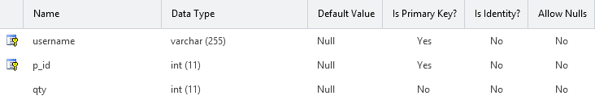

Table inventory:

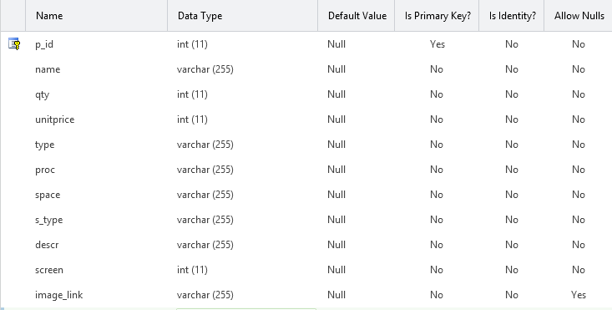

Table purchase:

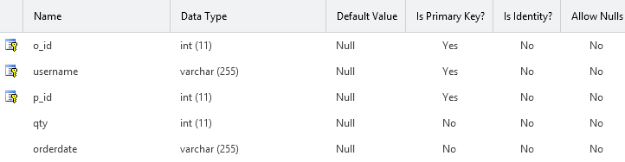

Table review:

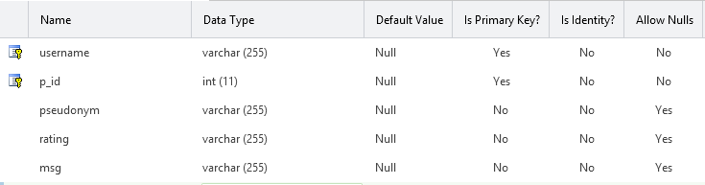

Table users:

